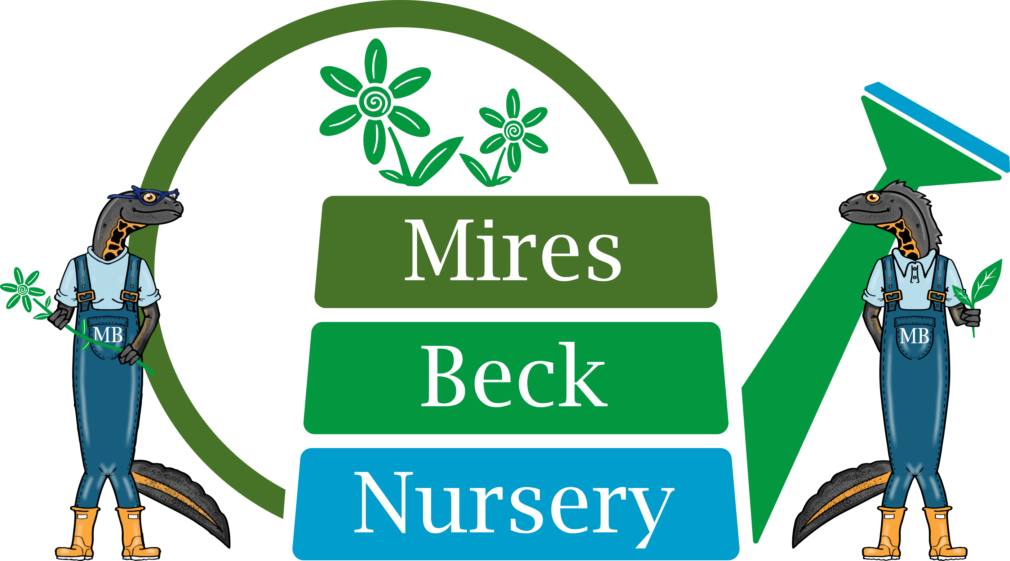

Low Mill Lane, North Cave, Brough, East Yorkshire, HU15 2NR
Tel. 01430 421543
www.miresbeck.co.uk
Email: sales@miresbeck.co.uk

Phragmites Prices 2023

 | Sherwood Rootrainer (175cc)
<50 | 85p
50+ | 80p
2,500+ | 70p

Prices exclude VAT which should be added at 20%

Free delivery on all orders over £500 net and within 50 mile radius of North Cave.

All plants grown in Peat-free compost.

Plants grown from seed of Yorkshire provenance

Plants grown to order.
Please order by March for delivery in July.

