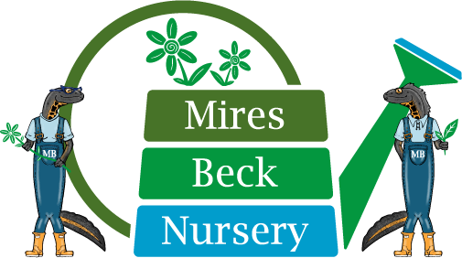

CORPORATE PACKAGES
- Mires Beck can offer one off attendance at the nursery for company employees who have a single charity day to use per year in a team of their choice, booked in advance by contacting Leanne@miresbeck.co.uk

- We can also work with companies who allocate more than one charity day per year to create an exposure to our work across countryside management and horticulture, when the company will book activities for their employees as teams. These are bespoke arrangements and can be discussed with Graham@miresbeck.co.uk Please use this route for group bookings.

- We can also organise team wellness days, or ‘Green Experience Days’ with our network of teachers who use our facilities such as Forest School activities, Yoga in the Woodlands, Art in Nature classes, Woodcarving and Photography. The price for the day is dependant on activity and whether arrival breakfast and lunch are required for the team. Please contact Carla@miresbeck.co.uk The per head cost for this package starts at £200 per person.

Please note: we are able to work with businesses that would be bringing opportunity to the charity through procurement of our stock, financial assistance by way of donation, or as onsite advertising, as a discretionary fee for employees to take part in team activities.
In each case, we ask people to come suitably dressed to be working in a rural nursery, looking at weather conditions and wearing sensible nonslip footwear.

Bronze 1-5 people
Attendance is charged at £20 pp.
This cost includes site fact sheet, working as part of a team with our service users, provision of basic PPE and refreshments.

Silver 6 – 12 people
Attendance is charged at £30 pp.
This includes training session presented by MB and certificate of attendance.
Site fact sheet. Working with a staff member as a team on a specific area of our operation, be that horticulture or Estates work. Provision of relevant PPE and refreshments.

Gold 12 – 20 people
Attendance is charged at £50 pp.
This includes training session presented by MB and certificate of attendance.
Site fact sheet. Working as two teams be that in horticulture, Estates or on specific project work. Provision of relevant PPE and refreshments.
(additional washroom cleaning costs apply)

Platinum 20 – 40 people
Attendance is charged at £60 per person.
This includes training session presented by MB and certificate of attendance.
Site fact sheet. Working in three teams be that horticulture, Estates, or specific project work. Provision of relevant PPE and refreshments.
(additional washroom cleaning costs apply)

