How to Make Gingerbread Reindeer
Ingredients
- 350g plain flour
- 2 teaspoons of ground ginger
- 1 tablespoon of bicarbonate of soda
- 150g soft dark brown sugar
- 125g diced butter
- 4 tablespoons golden syrup
- 1 medium egg (beaten)
- 2 tablespoons of icing sugar or ready made icing from the shop
- Food colouring
- Sweets /currants to decorate

Instructions
- Preheat your oven to 180°C or 350°F or gas mark 4
- Line your baking tray with baking paper
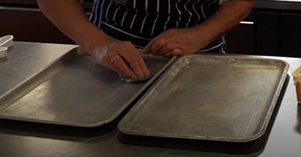
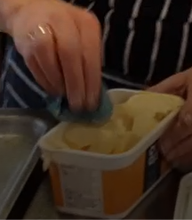

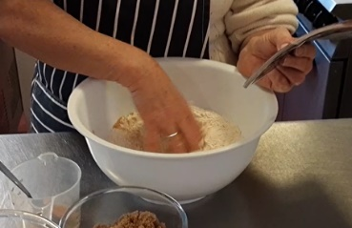
- Mix the flour, ginger and bicarbonate of soda together with your hands

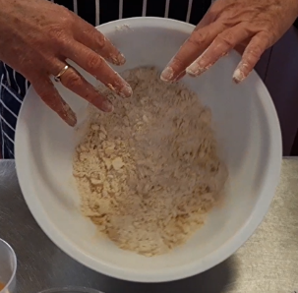
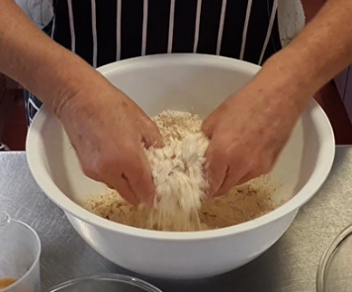
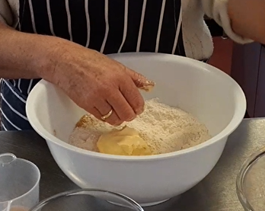
- Use your hands to mix in the butter until the mixture turns into breadcrumbs

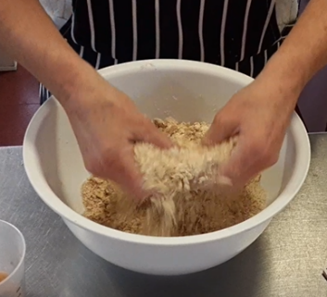
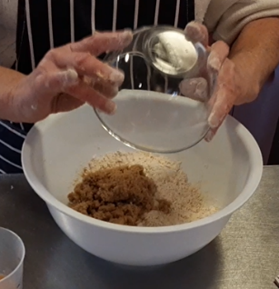
- Stir in the dark brown sugar

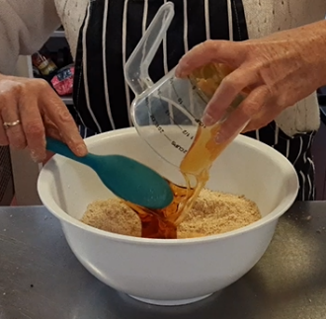
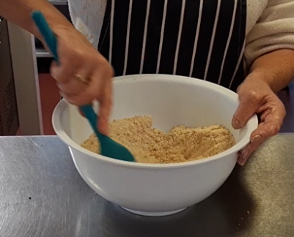
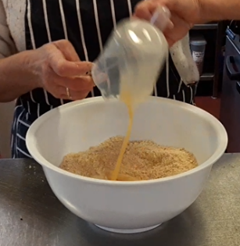
- Add the golden syrup and egg, and mix it with a spoon until it turns into dough

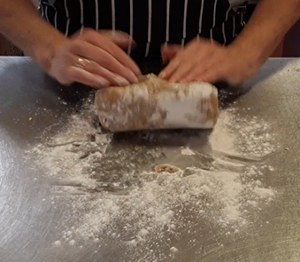
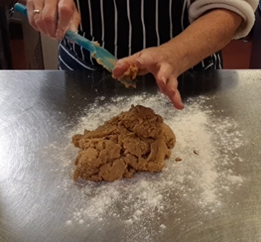
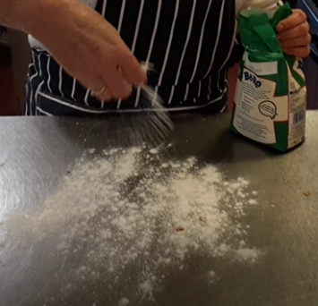
- Very carefully pour a bit of flour onto a clean flat surface, put the dough on the floured surface and knead it until it’s smooth

- Using a rolling pin, roll the dough until it’s 5mm thick
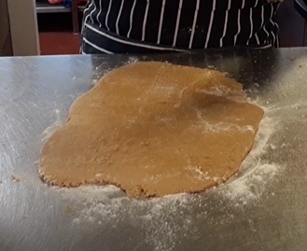
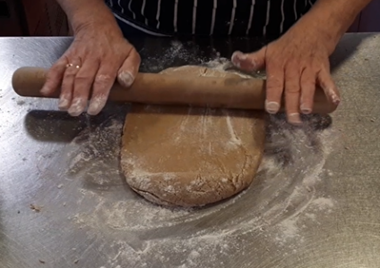

- Use a gingerbread man cutter to cut out the shapes
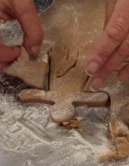
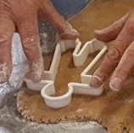

- You can re-roll the leftover dough to make more gingerbread men or biscuits
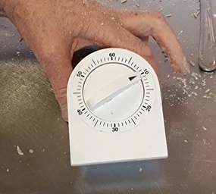
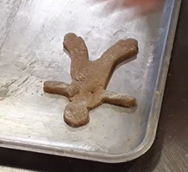
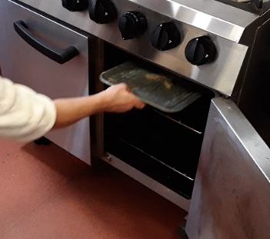
- Put these on your baking tray, and put them in the oven for 10 minutes or until they look golden

- Wait for them to cool down, then turn them upside down
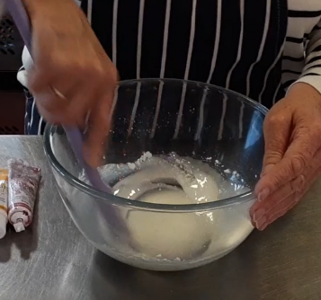
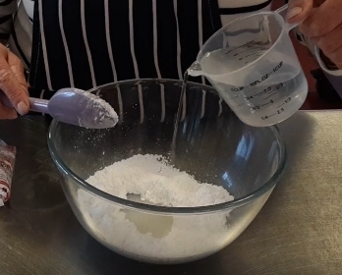
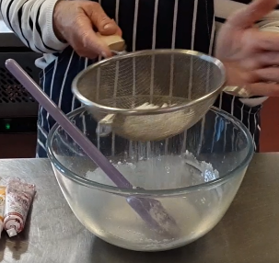
- Sieve your 2 tablespoons of icing sugar into a different bowl, pour a little water on it and mix it until it’s runny – if it’s too runny, sieve more icing sugar into it and mix again

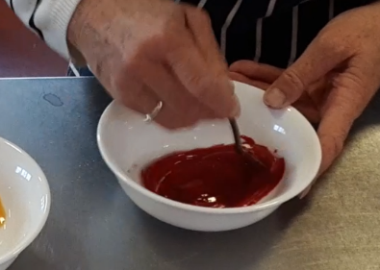
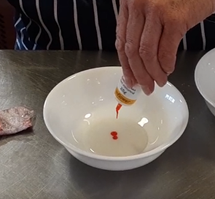
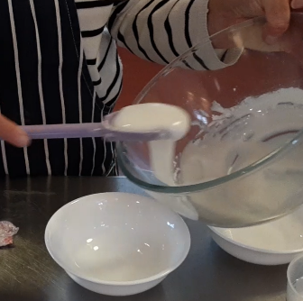
- If you would like to decorate your gingerbread reindeer with different colours, you can mix a few drops of food colouring into your icing

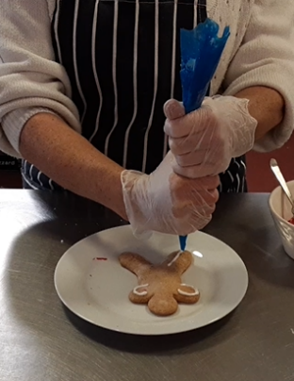
- You can put some of your icing into an icing bag (or different icing bags for your different coloured icing), and decorate your reindeer as you would like to
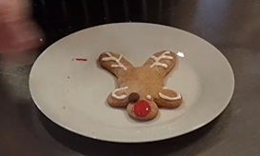
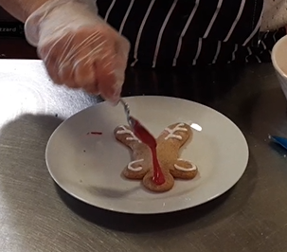

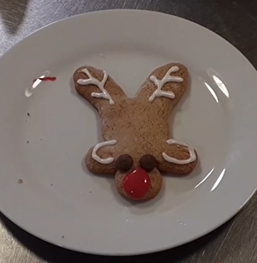
- Add your sweets or currants if you would like to, to decorate your reindeer
Here is an idea on what your reindeer could look like:

