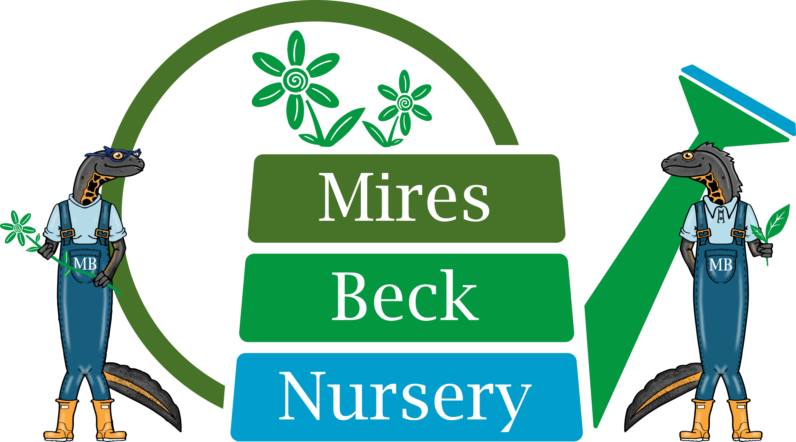

Minibus Driver
Job Description

The Relief Minibus Driver is responsible in the first instance to the Support Services Manager. Your specific duties include:

- drive a vehicle as supplied by the company to transport service users home from
the nursery on a daily basis

- drive the vehicle to transport staff and service users on day-visits as and when
required

- be responsible for the well-being of service users at all times

- drive in accordance with the company’s minibus policy

- ensure that all regular routine safety checks as detailed in the Safety Checklist are
carried out and the findings recorded, reporting any defects promptly to the
Support Services Manager.

- drive in accordance with legal requirements.

- report immediately any accidents or incidents involving the company vehicle,
including any damage to the vehicle, to the Support Services Manager.

- drive in accordance with legal requirements.

- ensure compliance with health and safety regulations.

- attend meetings as required.

This Job Description will be reviewed and developed on a regular basis, at least
annually, to reflect the on-going development of the organisation.

Signature……………………………………. Date……………………………….

Name………………………………………....

Date Prepared: June 2014
Reviewed: March 2021

