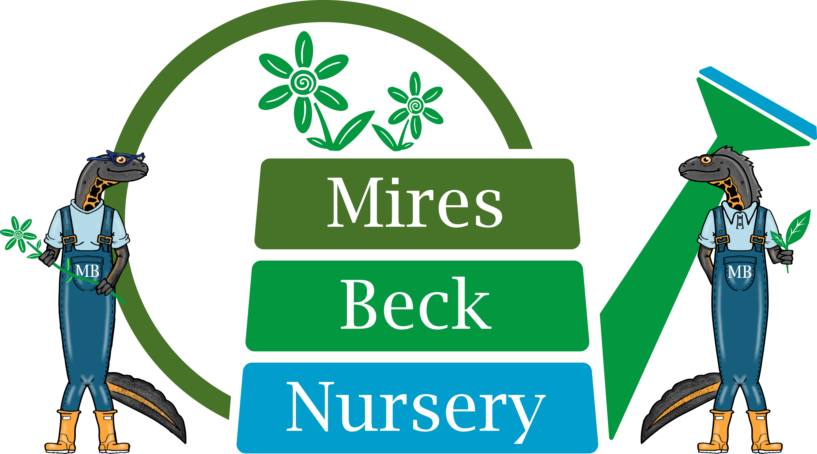

1:1 Support Worker
Job Description

The 1:1 Support Worker is responsible in the first instance to the Supervisor/Team Leader.

The specific duties of the 1:1 Support Worker are:

- to work under the guidance of the Supervisor/Team Leader to provide close support and supervision to one service user.

- to enable the service user to develop skills, and a pride in what they can achieve.

- to help maintain a good standard of plant husbandry and tidiness in the work area.

- to ensure proper health and safety procedures are carried out as instructed by the Supervisor/Team Leader.

- to ensure the well-being of the service user at the nursery at all times.

- to report any safeguarding concerns in line with Mires Beck Nursery’s Incident Reporting Procedure and Safeguarding Policy.

- to assist with personal care of the service user.

- to undertake appropriate, and mutually agreed, courses of training.

- to participate in meetings.

- to maintain confidentiality.

- other reasonable duties involved in the general running of the nursery.

This Job Description will be reviewed and developed on a regular basis, at least annually, to reflect the on-going development of the organisation.

Signature……………………………………. Date……………………………….

Name………………………………………....

Date Reviewed: March 2022

