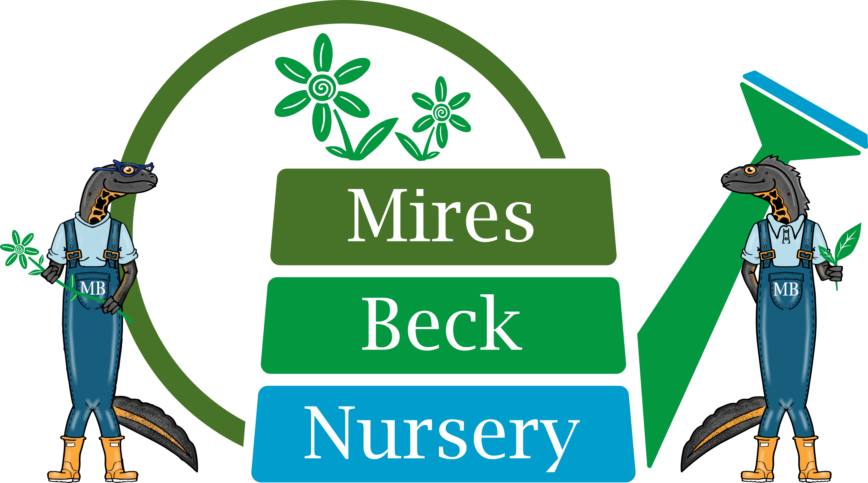

Relief Support Worker
Job Description

The Support Worker is responsible in the first instance to the Supervisor of the Team that they are working in. This is a relief post, working on an as and when required basis. The working day is 6.5 hours from 9.00 am to 4.00 pm, with a 30 minute unpaid lunch break.

The specific duties of the Relief Support Worker are:

- to work under the guidance of the Supervisor to provide the support and supervision required by service users.

- to enable service users to develop skills, and a pride in what they can achieve.

- to help maintain a good standard of plant husbandry and tidiness in the work area.

- to ensure proper health and safety procedures are carried out as instructed by the Supervisor.

- to ensure the well-being of all service users at the nursery at all times.

- to assist with personal care of service users.

- to undertake appropriate, and mutually agreed, courses of training.

- to participate in team meetings.

- to maintain confidentiality.

- other duties involved in the general running of the nursery.

This Job Description will be reviewed and developed on a regular basis, at least annually, to reflect the on-going development of the organisation.

Signature……………………………………. Date……………………………….

Name……………..…..………………....

Date Reviewed: July 2019

