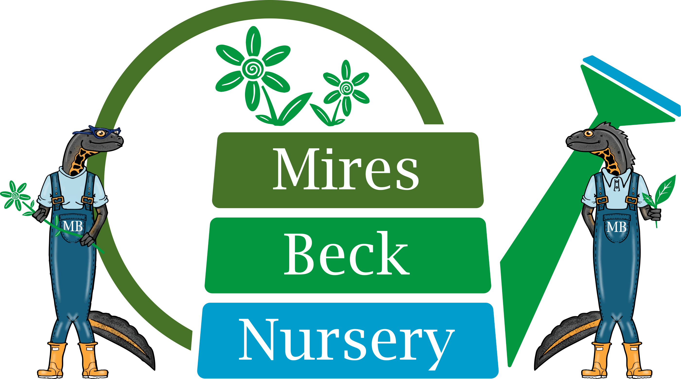
Background Information
Horticulture Supervisor

Mires Beck Nursery is a registered charity with the primary object of providing horticultural training and work experience for its service users. These are people who have a range of disabilities including those with learning difficulties, and those who are recovering from mental health problems. The nursery which was founded in 1984, is situated on the outskirts of North Cave and has operated as a charity since 1994.

The aim and purpose of Mires Beck Nursery is to provide a caring and supportive, yet realistic working environment within our commercial nursery, where people can develop skills and grow in confidence and self-esteem. Our responsibility is to grow the charity and its reserve to sustain its place in the community for the long term.

There has been a continual development of the facilities at the nursery which now include a central charity hub, a range of glasshouses and ancillary buildings. Now in our 27th year of operation, we have 40 members of staff (FTE of 20), 100 service users and 40 volunteers actively involved at the nursery. The nursery produces a wide range of plants and trees which are sold to the public, garden centres and other organisations.

We are immensely proud of our achievements ranging from a Queens Award for Volunteering, accredited as a Garden of Sanctuary by City of Sanctuary and this year shortlisted as a finalist in the Rural Business Awards. The COVID experience has made us more resilient, but equally adaptable to change and we will maximise all opportunity for growth. We are an ambitious charity and are looking for people to help us become even bigger and better equipped to navigate the future.

The tree nursery has grown significantly since 2019 to contribute supply of British cell grown trees to the Northern Forest and tree planting projects across Yorkshire. The current government focus on tree planting in our area, has created demand on the nursery requiring us to seek further production opportunities for this operation. In January 2022 we will take up residence in a nursery near Pocklington in the East Riding of Yorkshire and will be recruiting the key personnel to help us establish a successful satellite tree nursery operation for the charity.

The working hours are Monday to Thursday from 8.00 am to 4.30 pm and Friday 8.30 am to 4.00 pm with a 30-minute unpaid lunch break. The rate of pay is £10.70 per hour.

