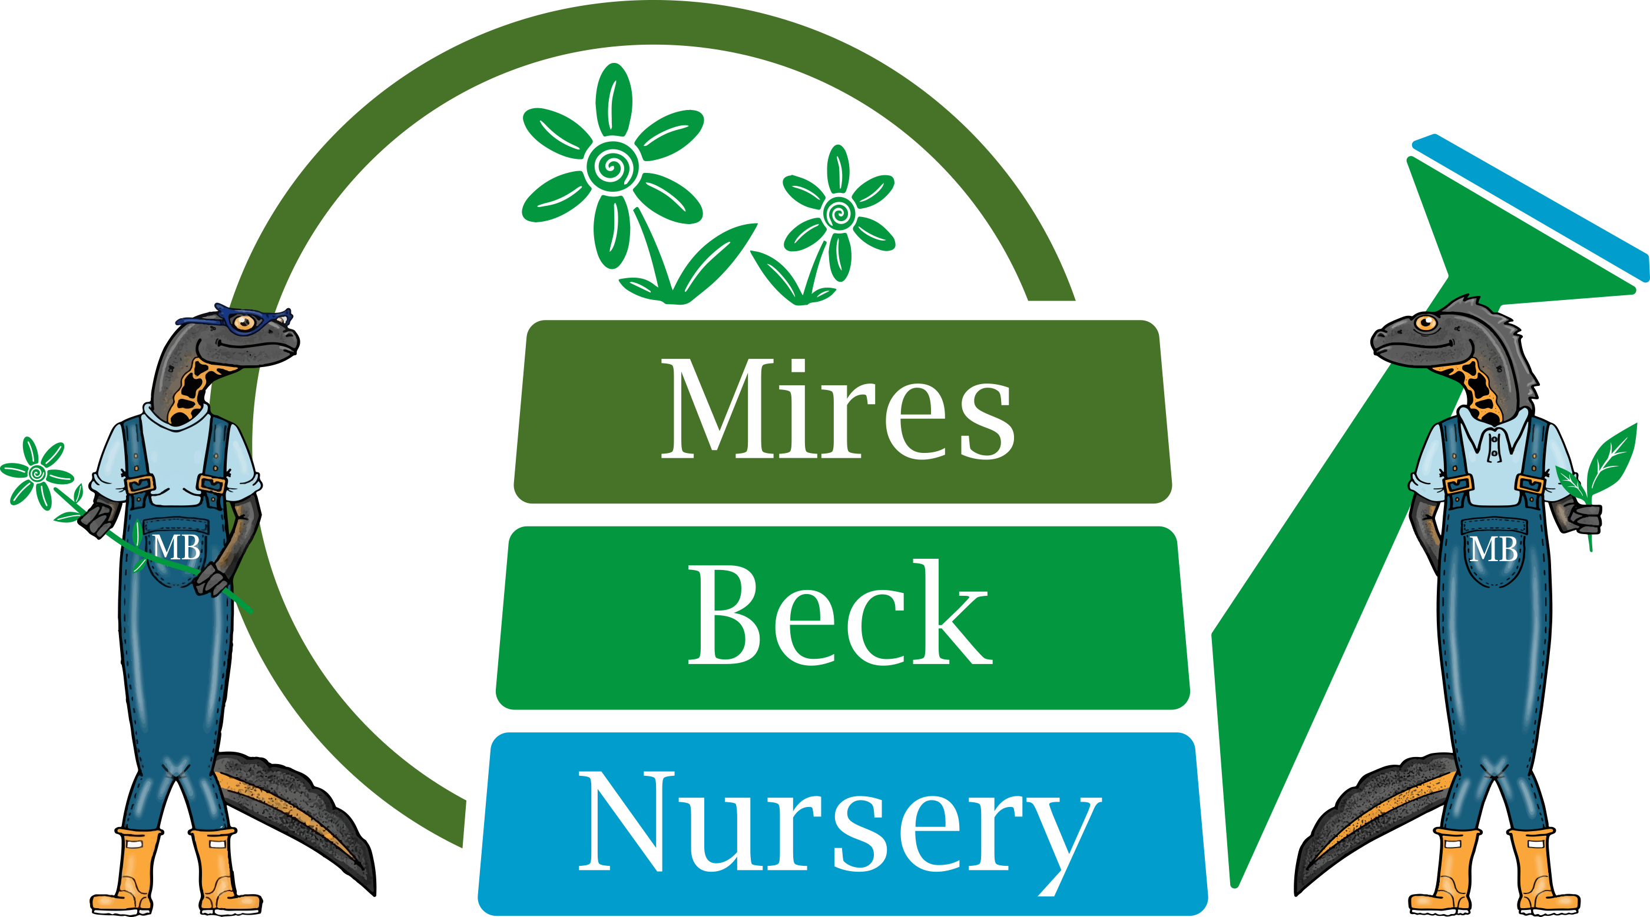
Background Information
Relief Minibus Driver

Mires Beck Nursery is a registered charity with the primary object of providing horticultural training and work experience for its service users. These are people who have a range of disabilities including those with learning difficulties, and those who are recovering from mental health problems. The nursery which was founded in 1984, is situated on the outskirts of North Cave and has operated as a charity since 1994.

The aim and purpose of Mires Beck Nursery is to provide a caring and supportive, yet realistic working environment where people can develop skills and grow in confidence and self-esteem.

There has been a continual development of the facilities at the nursery which now include a range of glasshouses and ancillary buildings. Now in our 27th year of operation we have 40 members of staff (FTE of 20), 100 service users and 40 volunteers actively involved at the nursery. The nursery produces a wide range of plants which are sold to the public, organisations and to garden centres.

We have a minibus for the purpose of bringing service users who live in Hull and the East Riding to the Nursery. The vehicle is a modern Peugeot Boxer 17 seater.

The minibus operates each weekday, morning and afternoon, transporting our service users from their homes in Hull to Mires Beck and then back home again.

Any prospective driver must have category D1 on their licence. This was normally included automatically for anyone taking their normal driving test before 1997. Anyone who has taken and passed their driving test after 1997 will probably not have category D1 on their licence and will therefore need to have taken an additional test to be able to drive a minibus.

The successful applicant will be required to pass a minibus driving assessment with our Vehicle and Maintenance Operative. She or he will also be required to drive in accordance with our own minibus safety policy. This policy does not allow the employment of a driver who has 6 or more points on their licence. Please detail any points on your licence in the ‘supplementary information’ section of the application form. The minibus driver must meet our insurance requirements.

Due to the nature of our client-group, the appointment is subject to an enhanced DBS check. A criminal record will not necessarily be a bar to obtaining employment.

We require to see the original driving licence or photocard of any applicant called for interview.

The rate of pay is £9.50 per hour. Working hours are:

Morning duty – 7.30 am to 9.30 am
Afternoon duty – 2.30 pm to 4.30 pm

All Mires Beck Nursery staff are currently required to undertake a Lateral Flow Test each morning, prior to attending Mires Beck.

This is a relief post, working on an as and when required basis to cover period of annual leave, sickness and covid isolation. We are under no obligation to offer shifts to you and you are under no obligation to accept shifts.

