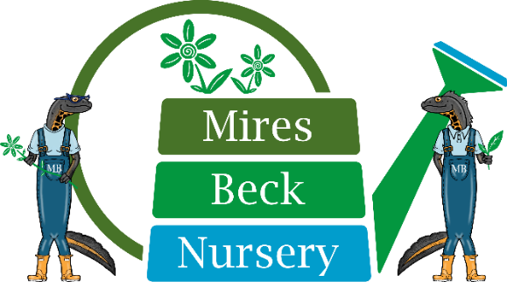
Low Mill Lane, North Cave, HU15 2NR

www.miresbeck.co.uk

Office: 01430 421543

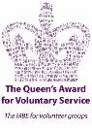
Company limited by guarantee
Registered in England & Wales No. 02928901

Registered Charity No. 1038078

Mires Beck Care
Our 4 pillars of care are centred on a recognisable set of actions which are aligned to the charity’s objectives.

C – Consideration and right action
- Adapting to suit individual needs
R – Recognition of unique abilities
E – Encouraging people to reach their full potential

Quality of Life
At Mires Beck our aim is to improve the quality of life for both our service users, parents and carers. Quality of life in the service we offer means to provide the ability to enjoy normal work life activities. Quality of life is an important consideration in medical care and green therapy is a means to maintain health as a consideration in quality living. The charity has a broad aim to provide the location and work experience gained at the nursery to people of all ages. We work alongside SEN schools to invite students of school leaving age the opportunity to have a place go and to grow. For those reaching their older years, our Anniversary Garden team offer more close supervision and activities which allow people to find their own pace and sense of enjoyment being involved in less physical horticultural tasks. For those able to work in various teams within the 14 acre grounds of the nursery, the exposure to fresh air and the outdoors it paramount to their health and maintaining physical ability.

Enrichment
We provide a routine and structure within the nursery operation to allow all people to engage with all aspects of the horticultural experience on offer. This provides the same opportunity as in in normal society for people to receive the training to learn about their work, achieve successful outcomes and be praised for their achievements. The added benefit of coming with your peers to a place of safety, is the freedom to express yourself amongst your friends and colleagues and learn from those around you without the scrutiny which many experience outside of a safeguarded environment. For more capable service users, the opportunity exists as in the normal work place to become a buddy for new people or those who may need a little more help in carrying out their tasks.
We are able to encourage those with unique skills as a result of their condition, to use them in their task work. The attention to detail which some people with Autism demonstrate, allows them the opportunity engage in precision tasks which brings reward in our plant labelling and sorting room for our customer orders. Our continuous learning in the subjects of Math’s and English are concurrent with the
production of plants and the measures included in maintaining plant health and dealing with work in conservation, retail and wholesaling of our stock. Information share with service users about Mires Beck and its operations are an all-day every day method to encourage communication skills and helps everyone to feel part of the whole nursery and knowledgeable about our activities on and offsite. The service users are very proud to belong to a community of like-minded people all engaged in the similar task to keep the nursery the beautiful and successful charity it has become.

Nurturing
Our wonderful staff have much experience of recognising the skill levels of our service users. They are able to adapt the tasks in hand to suit each individual, but with an aim to bring anyone needing this help to reach the same level of proficiency as others in their teams. They are careful to capture the successes as the person progresses and they are also focused to not lose sight of the learnings along the way. For many of our service users repetition is key, but for others newness is equally important and our staff are creative and enterprising in delivering varied and interesting ways to work on their plant production. The teams also regularly experience other therapy including arts, crafts and music. Our volunteers are keen to assist everything we do at the nursery and many have formed close bonds with the service users they care for. We equally recognise the work of our volunteers who commitment is of paramount importance to the charity.
Due to the close relationships the staff and volunteers develop with their teams, they are able to quickly identify changes in behavior and are able to report and monitor this under guidance. This enables our Support Services Manager to engage with the correct person or carer to discuss anything we think adverse to the service user’s usual pattern. Early sighting of change comes with knowledge of the service user and great care is taken to manage each individuals experience at the nursery. Equally we are able to celebrate at reviews all of the positive progress anyone is making and we operate a recognition programme for the service users achieving certificates and projects we set each season.
In line with Social Therapeutic Horticulture Principles delivered through Thrive we agree with the following impacts upon our service users.
- Better physical health through exercise and learning how to use or strengthen muscles to improve mobility
- Improved mental health through a sense of purpose and achievement
- The opportunity to connect with others – reducing feelings of isolation or exclusion
- Acquiring new skills to improve the chances of finding employment
- Just feeling better for being outside, in touch with nature and in the 'great outdoors'

