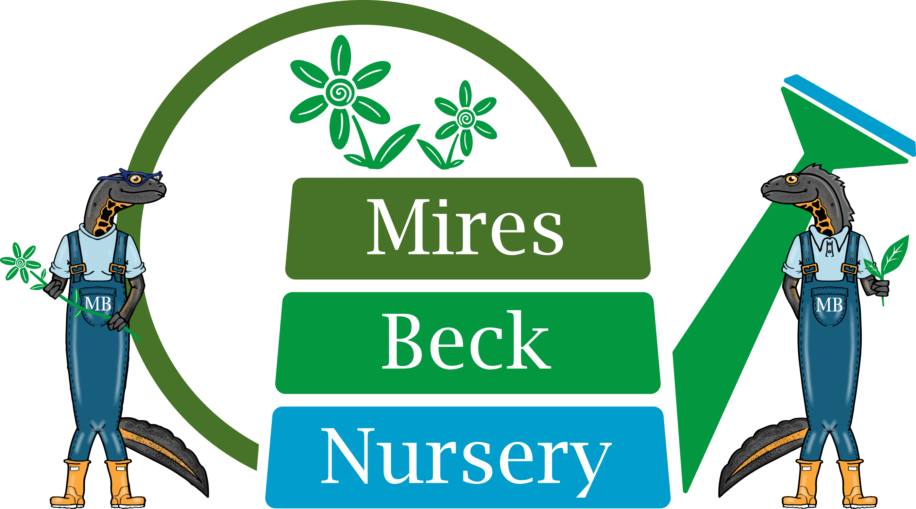

Sales Assistant
Job Description

This is a seasonal role until the 30th September. The hours are 9.45 am to 4.15 pm. You will be responsible to the Operations Manager.

The specific duties of the Sales Assistant are:

- Greet and welcome onsite customers, dealing with enquiries following the appropriate customer contact guidelines.
- Process sales, dealing with customers on an individual basis.
- Carry out end of day processing and update the appropriate records.
- Open and close the nursery at the beginning and end of the day at weekends and bank holidays.
- Dress and maintain sales benches following plant standard guidelines.
- Maintain the area around the sales benches including planted areas.
- Keep the sales hut clean and tidy.
- Ensure that the sales benches are watered appropriately.
- Monitor and ensure that the sales beds and glasshouses are watered appropriately over the weekends.
- Produce labels for onsite plant sales and garden centre orders.
- Processing payments for courses and events and assisting the course leaders where necessary.
- Assisting with shows and events.
- Monitoring stock levels of consumables for the till and card processing machine.
- Monitoring stock levels of consumables for the label printer.
- Ensure compliance with Health and Safety Regulations in own work area.

This Job Description will be reviewed and developed on a regular basis, at least annually, to reflect the on-going development of the organisation.

Signature……………………………………. Date……………………………….

Date Prepared: April 2016
Date Reviewed: March 2022

