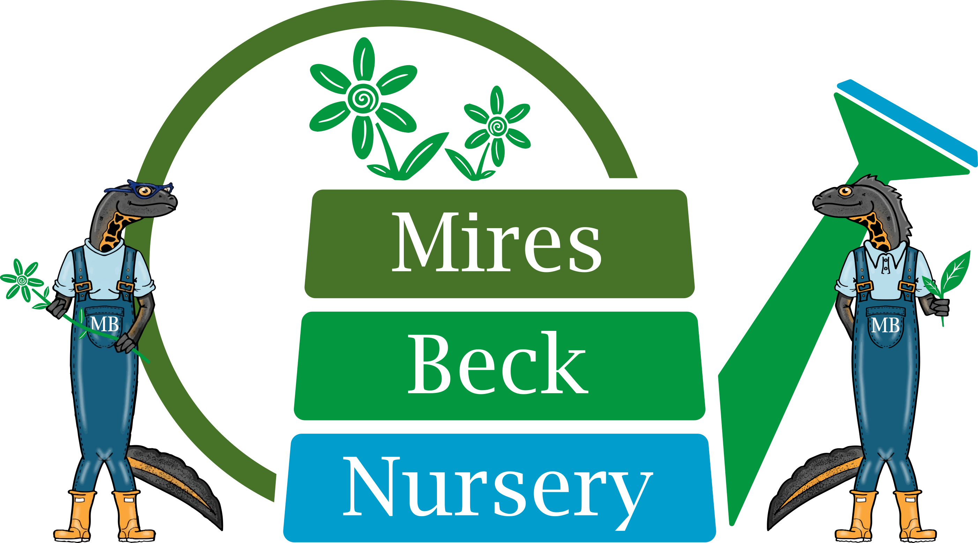
Background Information
Sales Assistant

Mires Beck Nursery is a registered charity with the primary object of providing horticultural training and work experience for its service users. These are people who have a range of disabilities including those with learning difficulties, and those who are recovering from mental health problems. The nursery which was founded in 1984, is situated on the outskirts of North Cave and has operated as a charity since 1994.

The aim and purpose of Mires Beck Nursery is to provide a caring and supportive, yet realistic working environment where people can develop skills and grow in confidence and self-esteem.

There has been a continual development of the facilities at the nursery which now include a range of glasshouses and ancillary buildings. Now in our 28th year of operation we have 45 members of staff (FTE of 20), approximately 90 service users and 40 volunteers actively involved at the nursery. The nursery produces a wide range of plants which are sold to the public, organisations and to garden centres.

Sales Assistant

The role of Sales Assistant is temporary until the end of September 2022. It is a shared position working 1 day per week from 9.45 am to 4.15 pm with a 30 minute unpaid lunch break.

The salary for this post is £9.50 per hour. Due to the nature of our client-group, the appointment is subject to an enhanced DBS check. A criminal record will not necessarily be a bar to obtaining employment.

Mires Beck Nursery January 2017
Date Reviewed: March 2022

