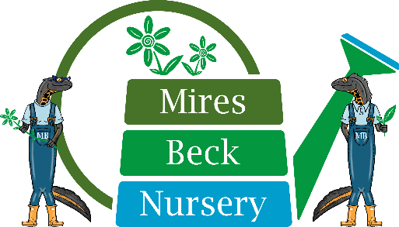

Weekend Watering Assistant
Role Description

Mires Beck Nursery are looking for some hands-on work at our Nursery in North Cave. We need volunteers to assist with the care and watering of our plants over the hot summer months, which is an essential task at the nursery. This is a seasonal volunteering role commencing from April 2023 until the end of August. 3 hours per day, Saturdays and / or Sundays. You do not require any qualifications, and all training will be provided.

The tasks of the Watering Assistant are:

- Monitor and ensure that the sales beds and plants in the glasshouses and polytunnels plants are watered appropriately over the weekends.
- Maintain plant care of sales benches following plant standard guidelines.
- Reporting any faulty equipment, damage, vandalism, or potential hazard / risk to the Site Manager.
- Keeping all the equipment hoses etc tidy after use.
- Make sure all the pots are standing and areas are organized.
- Ensure compliance with Health and Safety Regulations.
- Undertake appropriate, and mutually agreed, courses of training.

