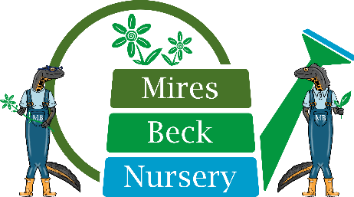

Ref: LP

4th March 2022

Dear Applicant

Post of Relief Support Worker

Thank you for your interest in the post of Relief Support Worker with Mires Beck Nursery.

This is a relief, zero hours contract post, working on an as and when required basis, to cover periods of sickness and annual leave. The salary for the post is £9.50 per hour. Working hours are 8.45 am until 3.45 pm, with an unpaid 30 minute lunch break.

If you are appointed to the post of Relief Support Worker, Mires Beck Nursery is not under any obligation to offer you any work. You are not under any obligation to accept work offered by us. Whilst a zero hours contract needs flexibility on both sides, we do not exclude relief employees who work for another employer.

Due to the nature of the work carried out by Mires Beck Nursery, if you are successful in your application, you will be required to undertake an Enhanced DBS Disclosure check. A criminal record will not necessarily be a bar to obtaining employment.

Please note that all staff employed by Mires Beck are currently required to do a Lateral Flow Test every morning before they attend Mires Beck and are required to wear PPE while supporting our service users.

We look forward to receiving your completed application form.

Yours sincerely

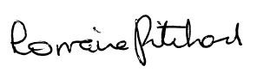

Lorraine Pritchard
Support Services Manager

Encs

